**MACHINE LEARNING PROJECT REPORT– CRN 31143**

**Project: Machine Learning with Natural disaster implementation on crop cultivation in the agricultural process**

**Team Members:**

|  |  |
| --- | --- |
| **Name** | **Student ID** |
| Akunuri Sri Priya | 700744712 |
| Sanath Kumar Ankala | 700744158 |
| Pravalika Medasani | 700744503 |

**Github Link:**  <https://github.com/Sri-Priya-Akunuri/Demo.git>

# ABSTRACT

Crop yield analysis is a rapidly developing research area. As per the National Policy on Disaster Management, agricultural impacts caused by natural disasters include a variety of occurrences like seismic activities, inundations, arid spells, tropical storms, tidal waves, slope failures, and snowslides. Seasonal and occasional catastrophes are the two types of disasters. Seasonal calamities such as weather and climatic variations such as rainfall pose consistent problems for farmers across the country. Natural disasters profoundly affect agriculture. Farmers aim to forecast their crop yield in diverse climate and disaster scenarios. " Natural catastrophes (earthquakes, floods, droughts, cyclones, tsunamis, landslides, and avalanches), weather, temperature, soil type, nutrient content, rainfall, and soil composition are all factors in our prediction study. We will employ diverse machine-learning techniques to train the collected data and develop a model. These data properties will be analysed and trained using multiple machine-learning methods to create the model." The system includes a model that is exact and reliable in forecasting crop production and providing the end user with suitable suggestions regarding the needed fertilizer ratio based on atmospheric and soil factors of the land, which improves crop yield and farmer revenue. In addition, the agricultural yield analysis system recognizes the value of incorporating remote sensing and satellite imaging data into its prediction models, which provide vital insights into vegetation health, crop growth patterns, and land cover changes. This integration broadens the system's awareness of agricultural situations while preventing plagiarism. The system can successfully handle and analyse enormous amounts of data using powerful machine learning algorithms, resulting in exact predictions. It considers not just natural destruction but also significant aspects involving weather patterns, temperature changes, soil properties, nutrient levels, rainfall distribution, and soil composition. These variables are crucial for predicting agricultural yield and identifying vulnerability to many environmental stresses. Furthermore, depending on the projected consequences, the system provides practical advice to farmers. The technology offers optimum fertilizer ratios for each land parcel based on unique atmospheric and soil parameters, which can improve crop output and eventually increase farmers' revenue. For positive results, this tailored method customizes solutions to individual farms, considering their unique characteristics and specific requirements. It helps farmers to make more informed decisions, lessen the adverse effects of natural catastrophes and climate change on their livelihoods, and contribute to sustainable agricultural practices. The system aims to assist farmers in maximizing crop yield while adjusting to ever-changing environmental circumstances by utilizing data-driven technology.

## KEYWORDS

Natural disaster, Crop cultivation, Random forest algorithm, Google Colab, Weather variations, Nutrient content and Sustainable agricultural practices.

### I. INTRODUCTION

Food generated through farming is critical to meeting humanity's fundamental requirements. Furthermore, crop cultivation is a crucial source of revenue for enterprises in the world. Horticulture, particularly in non-industrial nations such as the United States, is an important economic pillar and a considerable source of employment. The horticulture sector in India provides 15.4% of the country's GDP. Horticultural activities can be classified into three major categories: gathering, post-collection, and production. Progress in the field of machine learning has aided in the development of new agricultural advancements.

Machine learning is an ongoing innovation that assists farmers in minimizing cultivation mishaps by providing valuable insights and knowledge regarding crop yields. Machine learning in agribusiness enables more effective and precise cultivation with less human labor while producing high-quality results. Farming is a crucial pillar of the global economy and one of the most basic human needs, such as food. In many countries, farming is a substantial source of commerce. Many countries, for example, India, still cultivate traditionally; ranchers are unwilling to use cutting-edge innovations when farming because of a lack of information, a high cost, or because they are unaware of the advantages of these improvements.

Lack of knowledge on soil types, yields, harvests, climate, ill-advised pesticide use, faults in the water system, incorrect reaping, and a lack of market data led to ranchers incurring additional costs. Lack of knowledge at each phase of agriculture creates new challenges or widens existing ones, increasing the cost of production. According to the adage "Data is Power," monitoring data regarding harvests, climate, and markets may help ranchers make better decisions and shed light on horticultural challenges. The advantages of computer vision and machine learning will aid in increasing production, improving quality, and finally increasing the benefit of ranches and connected places. Accuracy learning is essential in the agricultural field to work on the overall collection yield. Machine learning and profound learning are the most recent arising patterns in the PC field. It has been utilized in various spaces like medical care, cybercrime, natural chemistry, mechanical technology, metrology, banking, medication, food, and so on to tackle the perplexing issues of scientists. By applying computerized machine learning, one may reduce the interest of machine learning experts and robotize the machine learning pipeline.

### II. MOTIVATION

Machine learning will be a Python-based program that will aid in the detection of natural disasters in agricultural production. It will be beneficial for agriculture to identify early and take essential activities at the appropriate time for cultivation. The goal of building a Python-based machine learning application to identify natural catastrophes in crop cultivation is to solve the agriculture sector's issues. Natural destructions such as floods, droughts, cyclones, and earthquakes can cause considerable damage to crops and agricultural infrastructure in agriculture. Early detection of these calamities is critical for mitigating their impact and allowing farmers to take timely and appropriate measures to safeguard their crops.

The importance of the application stems from its capacity to examine and assess the efficacy of machine learning algorithms in anticipating natural catastrophes and their influence on agricultural production. We can measure the dependability and efficiency of these algorithms in providing early warning systems for farmers by measuring their accuracy. This review method enables us to fine-tune and enhance the algorithms, accuracy, and better forecasts.

The application is written in Python and hosted on Google Colab, a cloud-based platform, to ensure accessibility and convenient use. It eliminates the requirement for users to install software and allows them to execute the program directly in their web browsers. Colab's machine-learning libraries provide tools for training and deploying prediction models. By successfully building this machine learning application, we want to provide the agricultural community with a vital tool for recognizing and minimizing the impact of natural catastrophes on crop production. Early identification of possible hazards and the capacity to take proactive steps would improve agricultural resilience, preserve livelihoods, and contribute to the agriculture sector's sustainability and productivity.

### III. OBJECTIVES

1. To study agricultural cultivation affected by recurring seasonal

catastrophes like weather variations, including rainfall, causing consistent problems for farmers nationwide.

1. To study the effects of occasional disasters, such as tsunamis, on agricultural cultivation and their significant impact on the agricultural sector.
2. Examine the relevant qualities employed in prediction analysis, including earthquakes, floods, droughts, cyclones, tsunamis, landslides, and avalanches.
3. Conduct data analysis considering weather conditions, temperature, soil type, nutrient content, and regional rainfall to determine the optimal crop selection for planting.

### IV. MILESTONE DIVISION AND INDIVIDUAL CONTRIBUTIONS

This project's milestones will be as follows:

1. Project preliminary research and design: This step will entail getting the crop cultivation disasters dataset and cleaning it using pre-processing procedures. (**Contributor**: Sanath Kumar Ankala - 700744158)
2. Project flow design: Create a project flow design with work flow. (**Contributor**: Sanath Kumar Ankala - 700744158)
3. Data analysis and visualization: In this phase, the natural disaster with crop dataset comprising the information from the natural disaster details report will be analyzed and visualized, and the we will compare the findings to the graphical reports. (**Contributor**: Pravalika Medasani – 700744503)
4. Machine learning algorithm selection and implementation: This phase will entail selecting appropriate machine learning algorithms for natural catastrophes analysis and disaster detection.(**Contributor**: Pravalika Medasani – 700744503)
5. Model assessment and refinement: The produced models are reviewed based on accuracy scores and refined to improve performance. (**Contributor**: Akunuri Sri Priya – 700744712)
6. Documentation and final report: The last phase will entail documenting the project and writing a complete report describing the process, outcomes, and findings. (**Contributor**: Akunuri Sri Priya – 700744712)

### V. RELATED WORK

**Significance:**

The project is analyzed using the Machine learning algorithm results. Because the Machine Learning algorithm forecasts the sickness, the accuracy of the algorithm output deploys in evaluating the findings [4]. The accuracy score of the algorithm in the natural catastrophe with agricultural cultivation aids in the evaluation of the dataset. As the project runs on any computer system with an internet connection, the application is with Google Colab Python Tool.

There is no need to install any special software on the user's machine. The Colab Tool facilitates the development and execution of applications directly within the cloud server where the Python library files are present. Machine learning algorithm libraries are within Colab. It aids the project's usage of the Machine

Learning algorithm in natural disaster detection involving agricultural agriculture.

Furthermore, the project assessment will consider the relationship between the Machine learning algorithm's prediction findings and the illness outcomes. It will give significant information into the algorithm's performance. Furthermore, the accuracy score produced from applying the algorithm to the natural catastrophe dataset and agricultural cultivation data will assist in analyzing the dataset's quality.

The Google Colab Python Tool will be used to construct the application, allowing it to run on any computer system with an internet connection. It eliminates the requirement for particular software installations on user PCs and runs the program on the cloud server. This connection with Colab makes it easier to use the builtin Machine learning algorithm libraries for identifying natural catastrophes in agricultural production.

**Techniques Applied:** The work entailed investigating a natural catastrophe with a crop cultivation dataset and processing relevant information. Then, the creation of many models and the generation of predictions were carried out using the Machine Learning model [1][7]. The program uses the machine learning library and the Machine learning library Sklearn.

### VI. PROPOSED FRAMEWORK/DESIGN

**Analysis natural disaster with crop cultivation:**

It will begin with the segment and study each part to see its impact on the goal segment. We will also execute preprocessing and integrate design tasks at the relevant phase. The goal of doing a top-to-bottom exploratory investigation is to gather ready and clean data for improved Machine Learning exhibiting to achieve elite execution and summed-up models. As a result, it should begin with breaking down and preparing the dataset for anticipation.

**Modules:**

1. Collection of data sets
2. Data purification
3. Data Examination
4. Modeling with machine learning
5. Submit a report
6. **Collection of data sets:** We collected natural disaster information with agricultural cultivation datasets containing many variables from various natural catastrophes.
7. **Data** **purification:** The huge dataset contains more noisy and incorrect

data, which we will pre-process to provide a quality dataset for further trimming.

The data is cleaned and processed, with the first stage deleting null values.

1. **Data Examination:** Exploratory analysis is a process of thoroughly exploring and comprehending data and data relationships to make feature engineering and machine learning modeling stages easy and streamlined for

prediction. It aids in determining if our assumptions are correct or incorrect. In other words, it aids in hypothesis testing.

1. **Modeling with Machine learning:** Machine learning modeling helps determine the optimum method with the best hyperparameters to achieve maximum accuracy. We divide the dataset into two parts. We use 70% of the records as training to train the machine learning algorithm. The remaining 30% of the dataset is used for testing, which helps in the prediction process.
2. **Submit a Report:** The data is displayed based on the output of the Machine Learning algorithm, and the data is mapped with various graphs to analyze and represent the exact data for the forecast to the user. Matplot libraries map the results depending on the user's specifications.

#### VII. PROJECT EXECUTION PLAN

This work will analyze the agricultural catastrophe dataset. We will pre-process the dataset, removing noisy and null value data. Afterward, we will examine and prepare the data for further processing. The analysis will employ machine learning techniques.

**SYSTEM SPECIFICATION**

**HARDWARE REQUIREMENTS:**

* Processor Intel(R) Pentium(R) CPU G2010 @
* Clock Speed 2.80GHz
* RAM 2.00 GB
* Hard Disk 1 TB HDD
* Monitor 15.6 Inches
* Mouse Logitech B100 Wired Optical Mouse
* Keyboard keypad Full-size island keyboard with number pad
* Display Card Super Video Graphics Adapter

**SOFTWARE REQUIREMENTS:**

* Operating System : Windows 10
* Front-End Tool : Python in Google Colab

#### VIII. DATA DESCRIPTION

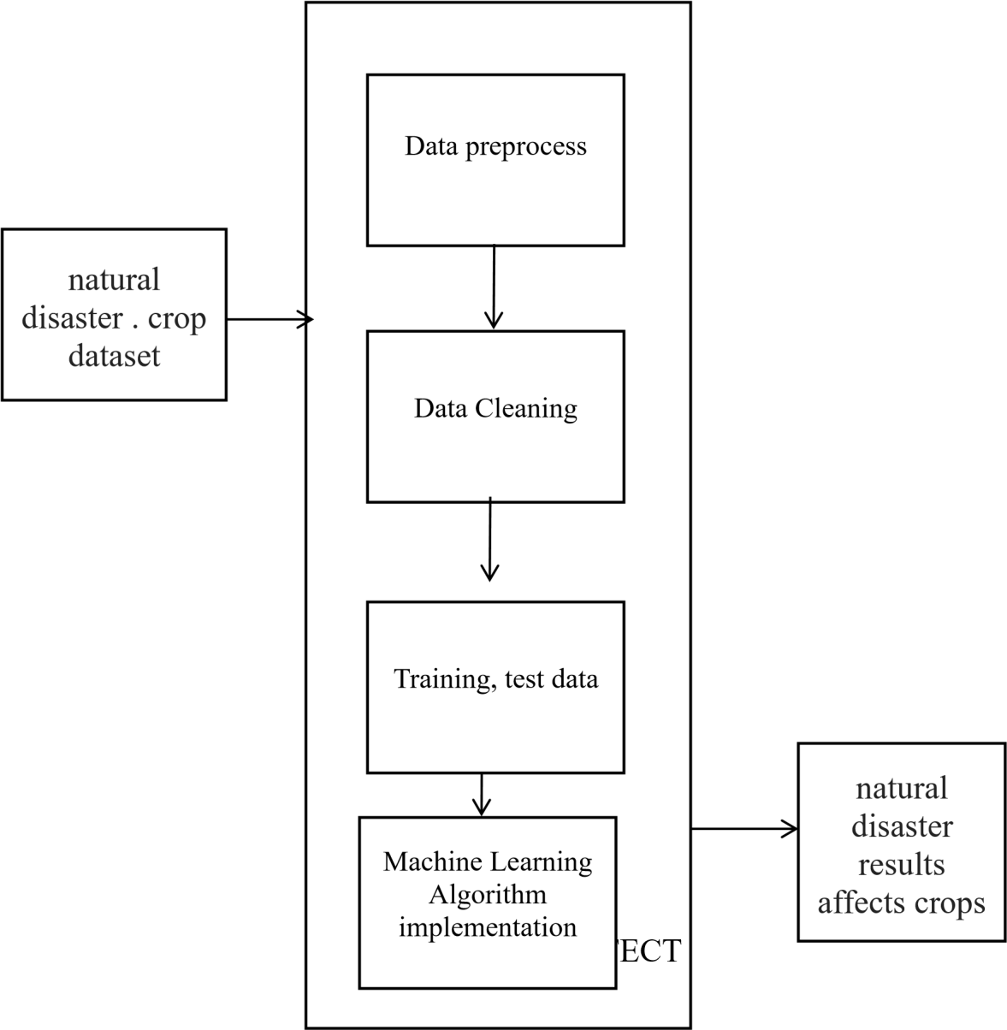

Figure 1: ARCHITECTURE DIAGRAM

After the training and test data are spitted out and passed into the Machine Learning algorithm, the natural disaster with crop cultivation affected is completed. All of this is shown in Figure 1.

**ALGORITHM USED**: Here we have used Supervised Random forest regressor algorithm.

**SYSTEM FLOW DIAGRAM**

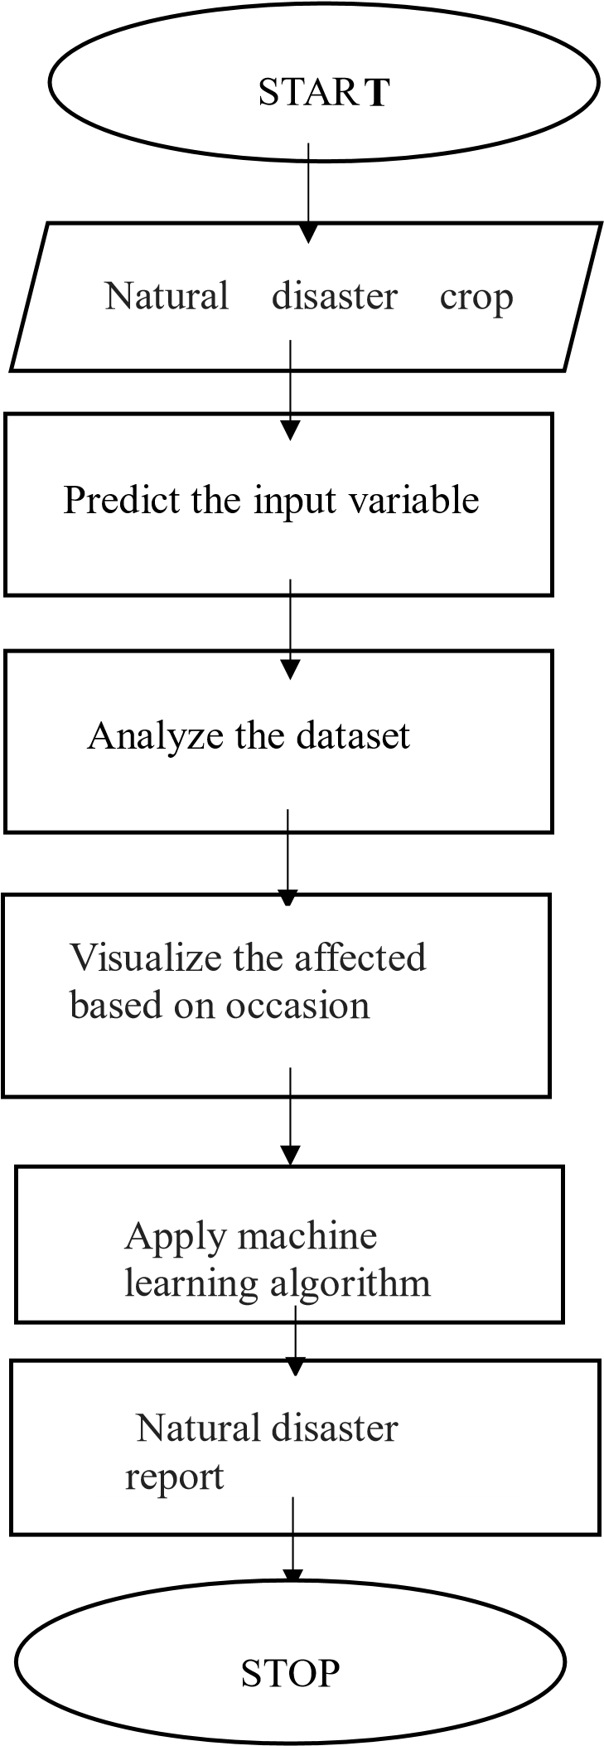

Figure 2: System Flow Diagram

**PROCESS FLOW : Load Packages:**

First step have to import the necessary packages to the application: # import packages #importing libraries import numpy as np import pandas as pd import matplotlib.pyplot as plt

#ML library from sklearn.linear_model import

LogisticRegression from sklearn.model_selection import train_test_split from sklearn import metrics

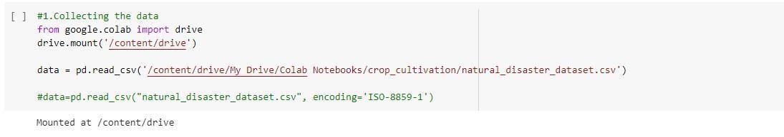

Figure 3. Collecting the data.

We link the dataset to Google Colab and upload it to the Google Colab folder. The Python program then connects to the directory of the Google Colab folder. We present the information in a simple style using components. When examining both numerical variables, a scatter plot provides a better understanding of their relationship. It reveals a weak link between the cost and size segments. Figure 4 displays the dictionary with the first five entries from the dataset, as shown by the head values.

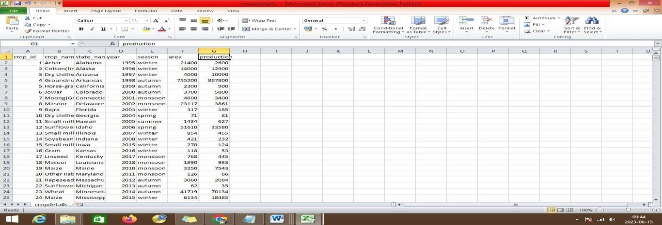

Figure 4. Records displayed with head values of first 5 records from the dataset.

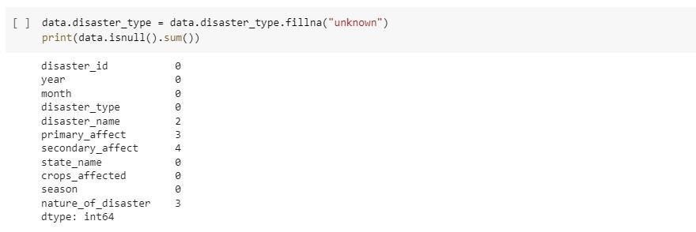

Figure 5. The crop details are dsiplayed with the graph based.

#### IX. IMPLEMENTATION/ METHODOLOGY

**Dataset:**

Many columns in a dataset are noisy and include data. However, doing feature engineering will yield better outcomes. The first step is to load data and import libraries. Following that, we will take a fundamental grasp of data such as its form, sample, and whether or not there are any NULL values in the dataset. Understanding the data is a critical factor in any prediction or Machine Learning endeavor. It's a good thing there are no NULL values. Dataset files have been obtained from the official website. The crop details dataset has 773 rows and 7 columns. The dataset natural_disaster_dataset.csv has 700 rows and 11 columns.

**Detailed Design of Features:**

This dataset contains the fields required for assessing the natural catastrophe with influence on agricultural cultivation dataset, as illustrated in figures 6 and 7. The

exploratory examination is a cycle that investigates and comprehends the information and information link in great depth to make a highlight design.

Exploratory inspection aids in supporting or debunking our assumptions.

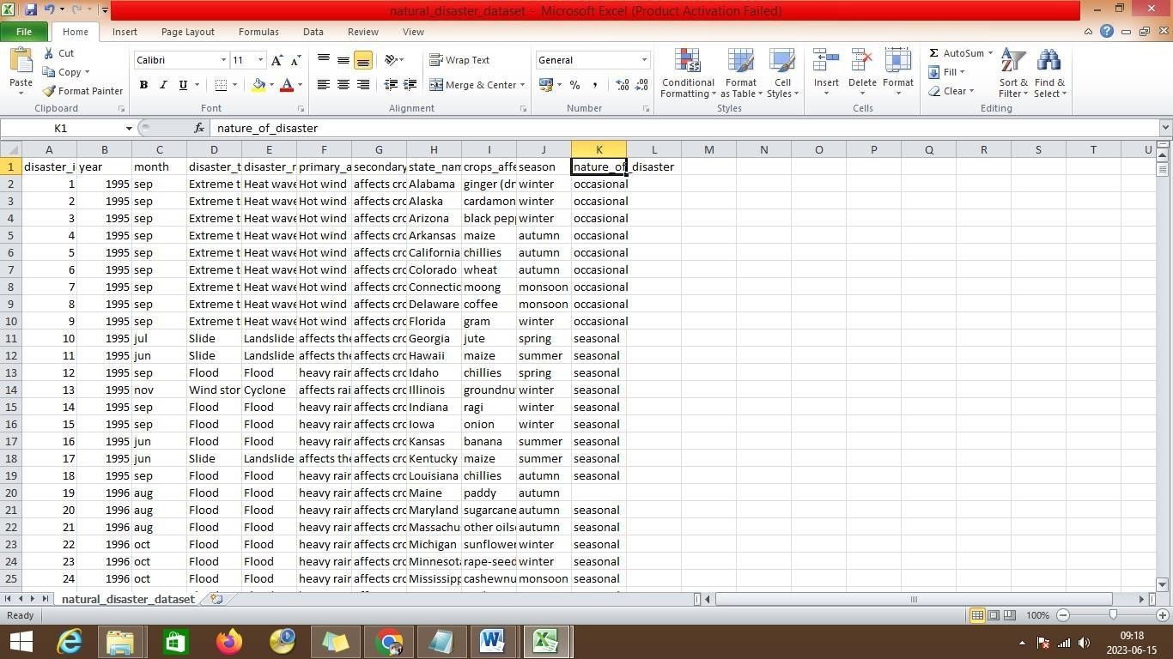

Figure 6 : crop dataset

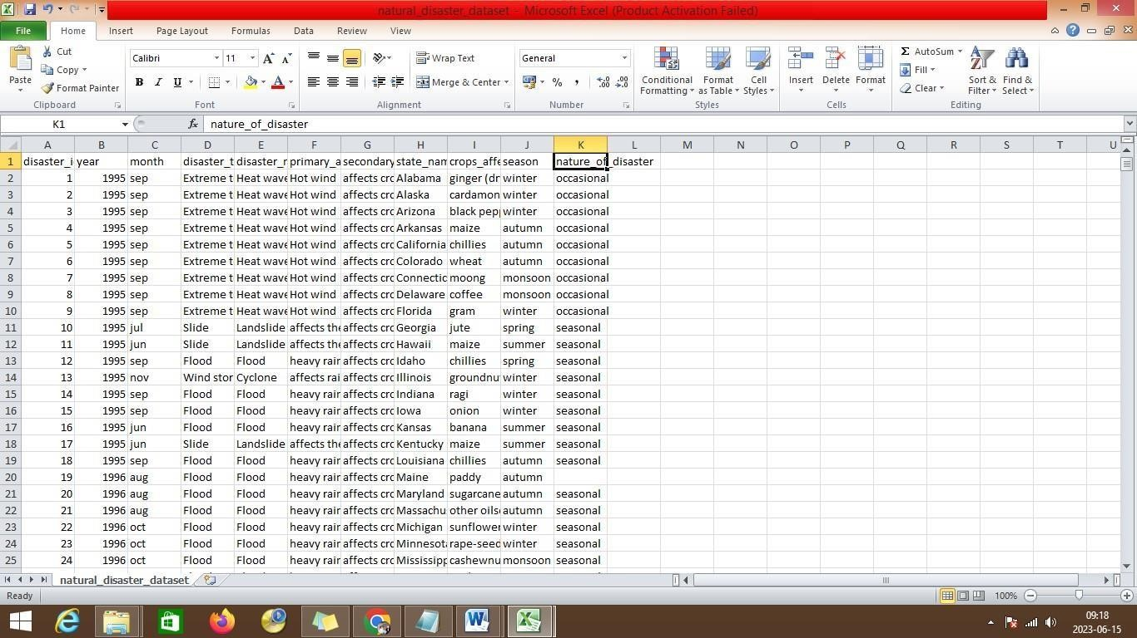

Figure 7: natural disaster dataset

After importing the dataset into the Python Colab, we perform the basic preprocessing to eliminate the noisy data. It is necessary to clean the Twitter messages since this information may be fragmented and cannot be supplied directly to the model. a) Remove digits, alphanumeric words, such as hello123, and numerals.

**Pre-processing:**

The noisy data, as well as the empty values in the cell, are pre-processed. The unnecessary columns are deleted for the model's evaluation using Python's drop function. Depicted in figures 8 and 9.

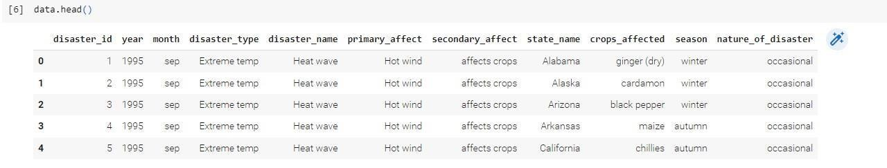

Figure 8. Displaying data.head()

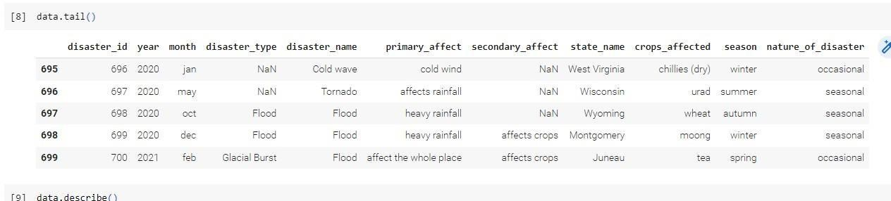

Figure 9. Displaying data.tail() **Data Visualization:**

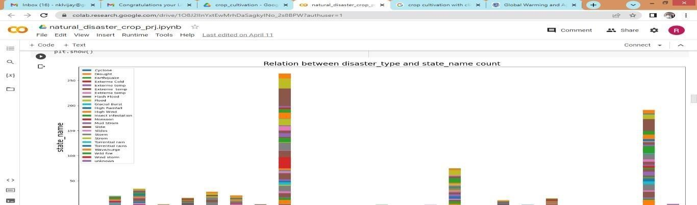

Figure 10. The product details are displayed based on disasters.

Based on the disaster types as shown in figure 10, the machine learning algorithms are applied.

**Data Describe:**

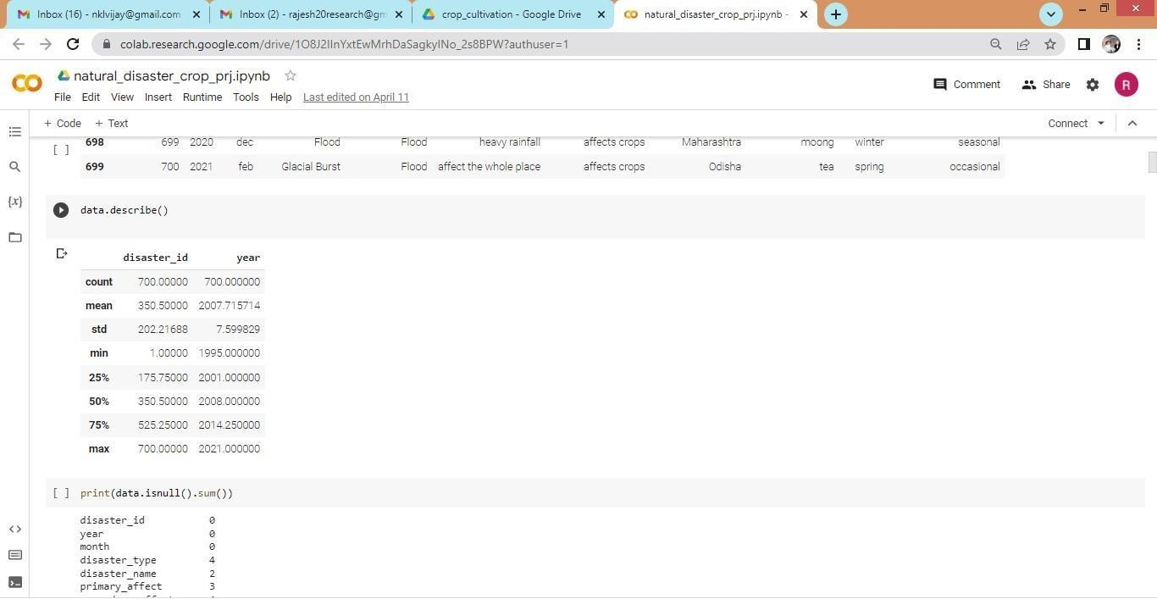

Figure 11. Describe()

As demonstrated in Figure 11, the describe function displays the maximum, minimum, and count values of the dataset columns, allowing for mathematical data analysis.

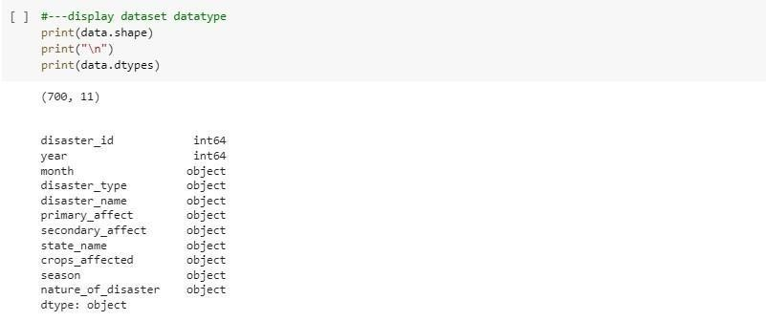

Figure 12. Display dataset type

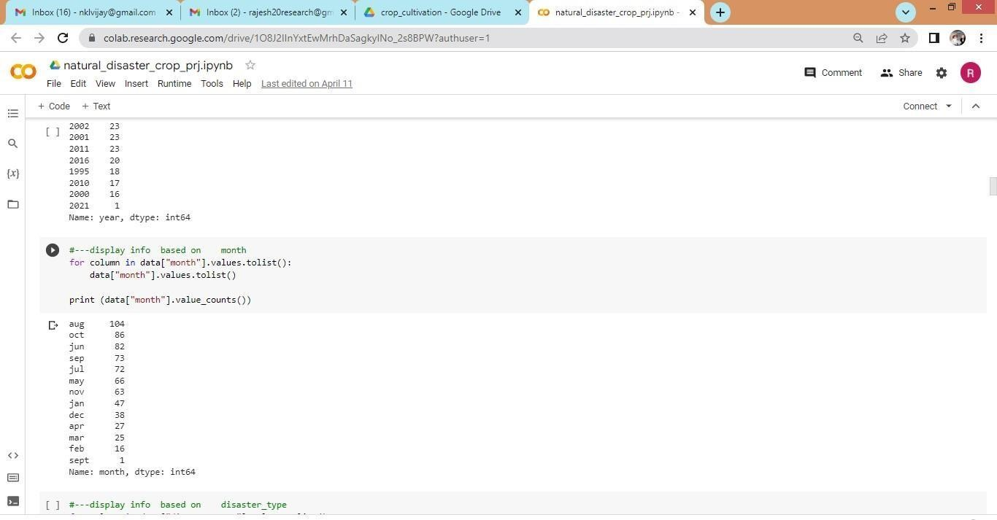

Figure 13. Displaying the information based on the monthly wise data.

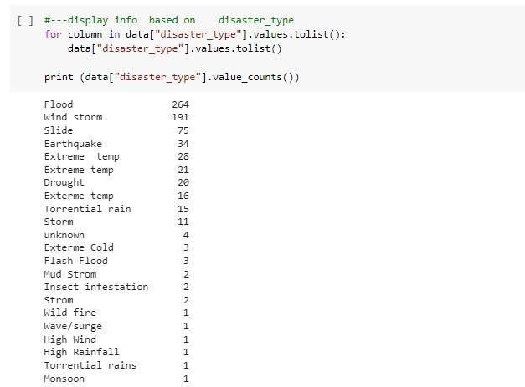

Figure 14. The results shows the information based on the disaster type.

#### X. EVALUATION

The project assessment may use the findings of the machine learning algorithm prediction. As the machine learning algorithm plays a crucial role in supporting agriculture, the evaluation of outcomes will depend on the accuracy of the algorithm's predictions. We will use the Google Colab Python Tool to create the application, enabling instant execution on any internet-connected computer system. Users do not need to install additional software on their machines. The Colab Tool facilitates the development and execution of the application directly within the cloud server, where the Python library files are stored. We construct the machine learning algorithm libraries within Colab.

##### XI. RESULTS / CRITICAL ASSESMENT

**Results based on Disaster Name:**

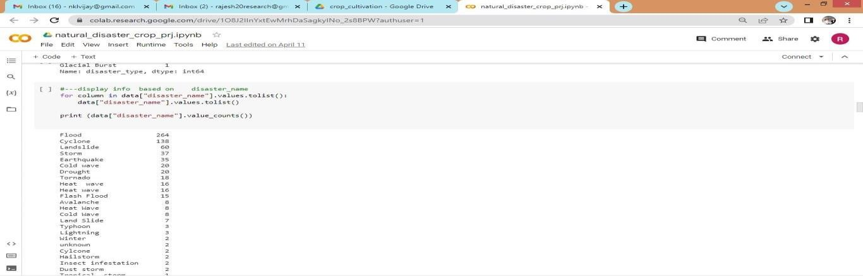

Figure 15. The results are displayed based on the disaster name.

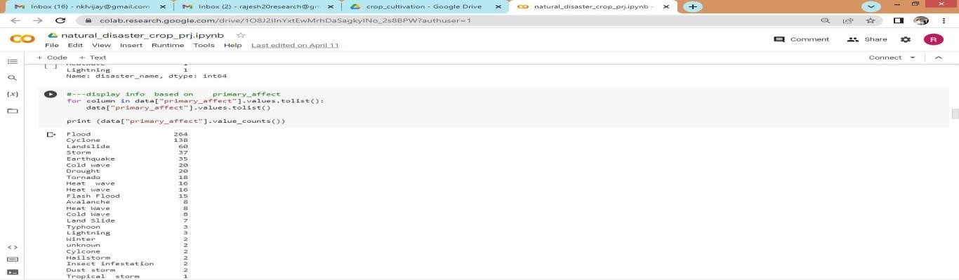

Figure 16. Based on the primary effect of the disaster the data is displayed.

**Results of Crops Affected:**

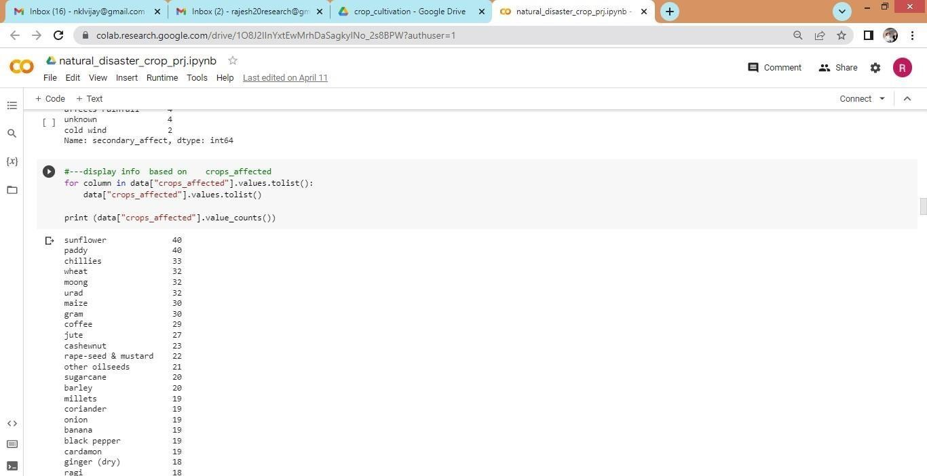

Figure 17. The result shows the crops affected in hector count in the geographical land area.

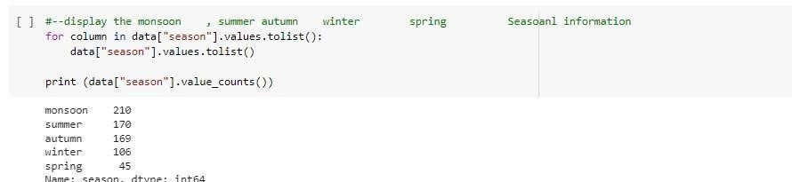

Figure 18. Seasonal based results displayed.

The seasonal based information is displayed based on:

* Monsoon
* Summer
* Autumn
* Winter
* Spring

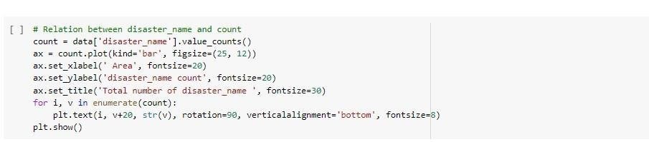

Figure 19. Implementation of Disaster type.

**Results:**

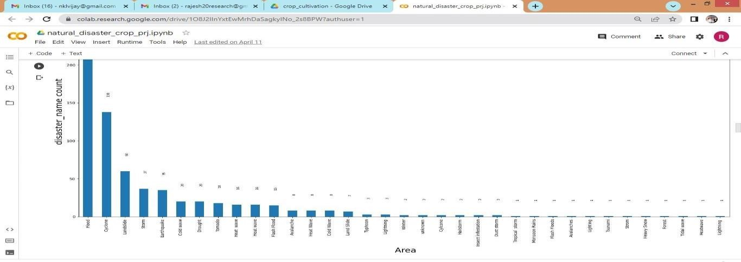

Figure 20. The results show the total number of disaster types and the name of the disaster with effect to the area.

**Implementation with between primary affect and secondary affect:**

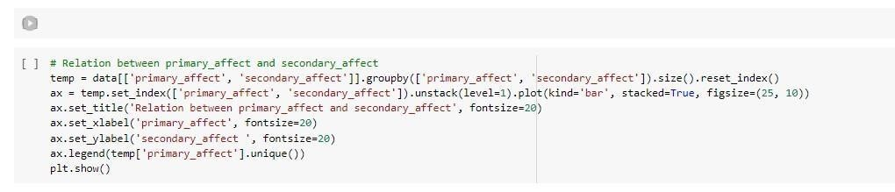

Figure 21. Relation between primary and secondary affects.

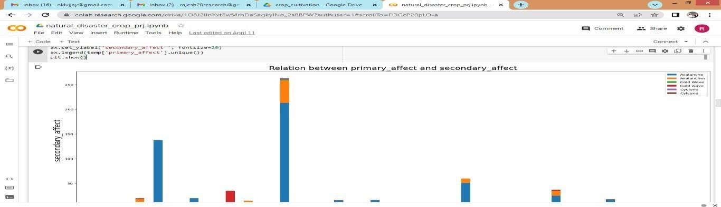

Figure 22. The implementation shows the primary affect with the secondary affect after the execution of machine learning algorithm.

**Results of Crops Affected:**

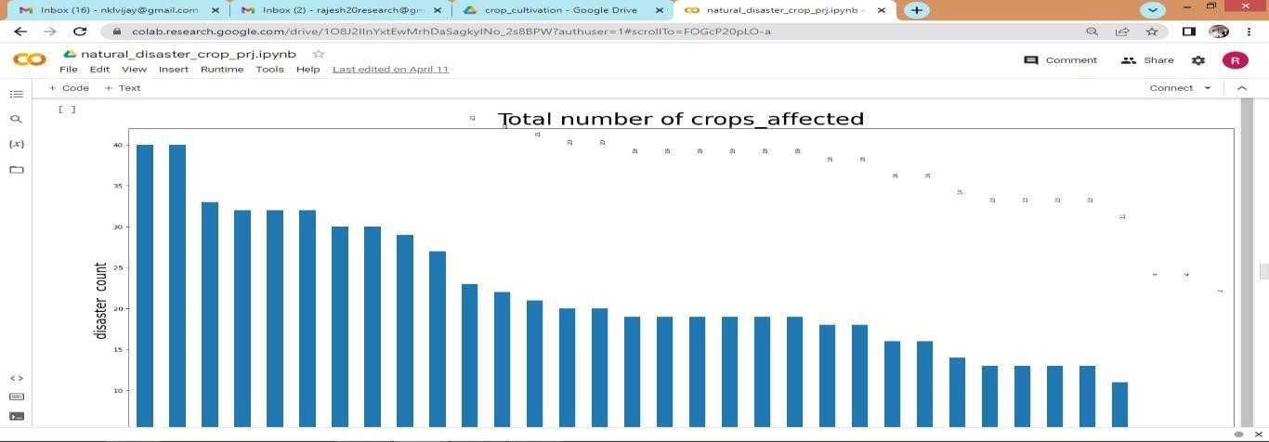

Figure 23. The graph displays the total number of crops affected due to the

disaster taken in the different type of states.

**ANALYSIS:**

It will begin from the principal segment and investigate every section and comprehend what influence it makes on the objective segment. At the necessary step, we will likewise perform preprocessing and include designing undertakings. The point in acting top to bottom exploratory examination is to get ready and clean information for better Machine Learning demonstrating to accomplish elite execution and summed up models. So it should begin with breaking down and

setting up the dataset for expectation.

##### XII. CONCLUSION AND FUTURE ENHANCEMENT / RECOMMENDATIONS

We examined the crop dataset, which consists of catastrophe reports, using several machine learning techniques and compared the findings with the graphical reports. Among other algorithms, the machine learning algorithm demonstrates the best results. We plan to expand the dataset in the future and assess the algorithm's performance. Additionally, we will collect and evaluate a large dataset in the future to improve accuracy levels.

##### XIII. REFERENCES/BIBLIOGRAPHY

1. Md Shah Jalal Jami[l;Af](https://ieeexplore.ieee.org/author/37086240840)ra Anik[a;Md](https://ieeexplore.ieee.org/author/38490005500). Saddam Hossain [Mukt](https://ieeexplore.ieee.org/author/38490005500)[a;Mohammad Nurul Huda,"E](https://ieeexplore.ieee.org/author/37408268500)nsemble of Classifiers Based Soil Evaluation for Crop Cultivation”, 2022 IEEE Region 10 Symposium
2. Sabbir Ahmed;Shamima Yesmin; Lata Rani Saha; A. K. M. Sadat;Mozammel H A Khan“Major Cropping Pattern Prediction in Bangladesh from Land, Soil and Climate Data Using Machine Learning Techniques”, 2022, 25th International Conference on Computer and Information Technology (ICCIT).
3. [Swati Vashish](https://ieeexplore.ieee.org/author/37085587728)[t;Praveen Kum](https://ieeexplore.ieee.org/author/37085348077)[ar;Munesh Chandra Trivedi “,](https://ieeexplore.ieee.org/author/37061253800) [Improvised Extreme Learning Machine for Crop Yield Prediction”](https://ieeexplore.ieee.org/document/9853054/) [2022- 3rd International Conference on Intelligent Engineering and Management (ICIEM).](https://ieeexplore.ieee.org/xpl/conhome/9853009/proceeding)
4. M. S. J. Jamil, A. K. M. M. Islam, B. Ahamed and M. N. Huda, "Iprocad: Intelligent prognosis of coronary artery disease excluding angiogram in patient with stable angina", *International Journal of Innovative Technology and Exploring Engineering*, vol. 9, no. 5, pp. 2032-2040, 2020.
5. Agriculture Extension Office, Kalapara, Patuakhali, Bangladesh, 2010. "Assessing the Costs of Climate Change and Adaptation in South Asia," Ahmed, M., and Suphachalasai, S.
6. M. Yang, D. Xu, S. Chen, H. Li and Z. Shi, "Evaluation of machine learning approaches to predict soil organic matter and ph using visnir spectra", *Sensors*, vol. 19, no. 2, pp. 263, 2019.
7. Agrawala, S, Ota, T, Ahmed, A.U, Smith, J, van Aalst, M (2003):Development and climate change in Bangladesh: focus on coastal flooding and the Sundarbans, OECD, Paris. Agriculture Extension Office, (2010): Kalapara, Patuakhali, Bangladesh.
8. Ahmed, M. & Suphachalasai, S, (2009): "Assessing the Costs of Climate Change and Adaptation in South Asia".

[9]. Suzuki N., Rivero R.M., Shulaev V., Blumwald E., Mittler R. Abiotic and

biotic stress combinations. *New Phytol.* 2014;203:32–43. doi:

10.1111/nph.12797.

[10]. Pachauri R.K., Allen M.R., Barros V.R., Broome J., Cramer W., Christ R., Church J.A., Clarke L., Dahe Q., Dasgupta P. *Climate Change 2014: Synthesis Report.* IPCC; Geneva, Switzerland: 2014. Contribution of Working Groups I, II and III to the Fifth Assessment Report of the Intergovernmental Panel on Climate Change.

[11]. Khan A., Ijaz M., Muhammad J., Goheer A., Akbar G., Adnan M. Climate Change Implications for Wheat Crop in Dera Ismail Khan District of Khyber Pakhtunkhwa. *Pak. J. Meteorol.* 2016;13:17–27.

[12]. Kanojia A., Dijkwel P.P. Abiotic Stress Responses are Governed by Reactive Oxygen Species and Age. *Annu. Plant Rev.* 2018:1–32. doi:

10.1002/9781119312994.apr0611.

[13]. Lesk C., Rowhani P., Ramankutty N. Influence of extreme weather disasters on global crop production. *Nature.* 2016;529:84. doi: 10.1038/nature16467. [14]. Altieri M.A., Nicholls C.I. The adaptation and mitigation potential of traditional agriculture in a changing climate. *Clim. Chang.* 2017;140:33–45. doi: 10.1007/s10584-013-0909-y.

[15]. Richardson K.J., Lewis K.H., Krishnamurthy P.K., Kent C., Wiltshire A.J., Hanlon H.M. Food security outcomes under a changing climate: Impacts of mitigation and adaptaion on vulnerablity to food insecurity. *Clim. Chang.* 2018;147:327–341. doi: 10.1007/s10584-018-2137-y.

[16]. Ito R., Vasconcelos H.L., Feeley K.J. Global climate change increases risk of crop yield losses and food insecurity in the tropical Andes. *Glob. Chang. Biol.* 2018;24:e592–e602.

[17]. Rogelj J., Den Elzen M., Höhne N., Fransen T., Fekete H., Winkler H., Schaeffer R., Sha F., Riahi K., Meinshausen M. Paris Agreement climate proposals need a boost to keep warming well below 2 °C. *Nature.* 2016;534:631.

doi: 10.1038/nature18307.

[18]. FAOSTAT. [(accessed on 2 August 2017)];2017 Available online:

<http://www.fao.org/faostat/en/#data>

[19]. Reckling M., Döring T.F., Bergkvist G., Chmielewski F., Stoddard F., Watson C., Seddig S., Bachinger J. Grain legume yield instability has increased over 60 years in long-term field experiments as measured by a scale-adjusted coefficient of variation. *Asp. Appl. Biol.* 2018;138:15–20.

[20]. Dhankher O.P., Foyer C.H. Climate resilient crops for improving global food security and safety. *Plant Cell Environ.* 2018;41:877–884.

doi: 10.1111/pce.13207. [[PubMed](https://pubmed.ncbi.nlm.nih.gov/29663504)[] [CrossRef]](https://doi.org/10.1111%2Fpce.13207) [[Google Scholar]](https://scholar.google.com/scholar_lookup?journal=Plant+Cell+Environ.&title=Climate+resilient+crops+for+improving+global+food+security+and+safety&author=O.P.+Dhankher&author=C.H.+Foyer&volume=41&publication_year=2018&pages=877-884&pmid=29663504&doi=10.1111/pce.13207&)

1. <https://colab.research.google.com/>
2. <https://www.tutorialspoint.com/google_colab/what_is_google_colab.htm>
3. [https://www.codingforentrepreneurs.com/courses/python](https://www.codingforentrepreneurs.com/courses/pytho)[googlecolabsheets-drive/](https://www.codingforentrepreneurs.com/courses/python-google-colab-sheets-drive/)
4. <https://www.kaggle.com/datasets/dataenergy/natural-disaster-data>